**Project Plan**

**1. Scope of Work:**

* **Objectives:**
  + Develop digital asset management system to facilitate the application, evaluation, and approval process for employee bursaries.
  + Enhance employee development opportunities and support the company's talent retention strategy.
* **Deliverables:**
  + Fully functional digital asset management system deployed on company servers.
  + User manuals and documentation for system administrators and end-users.
* **Constraints:**
  + Project must be completed within the allocated budget and timeline.
  + System must comply with company data security policies and regulations.

**2. Work Breakdown Structure (WBS):**

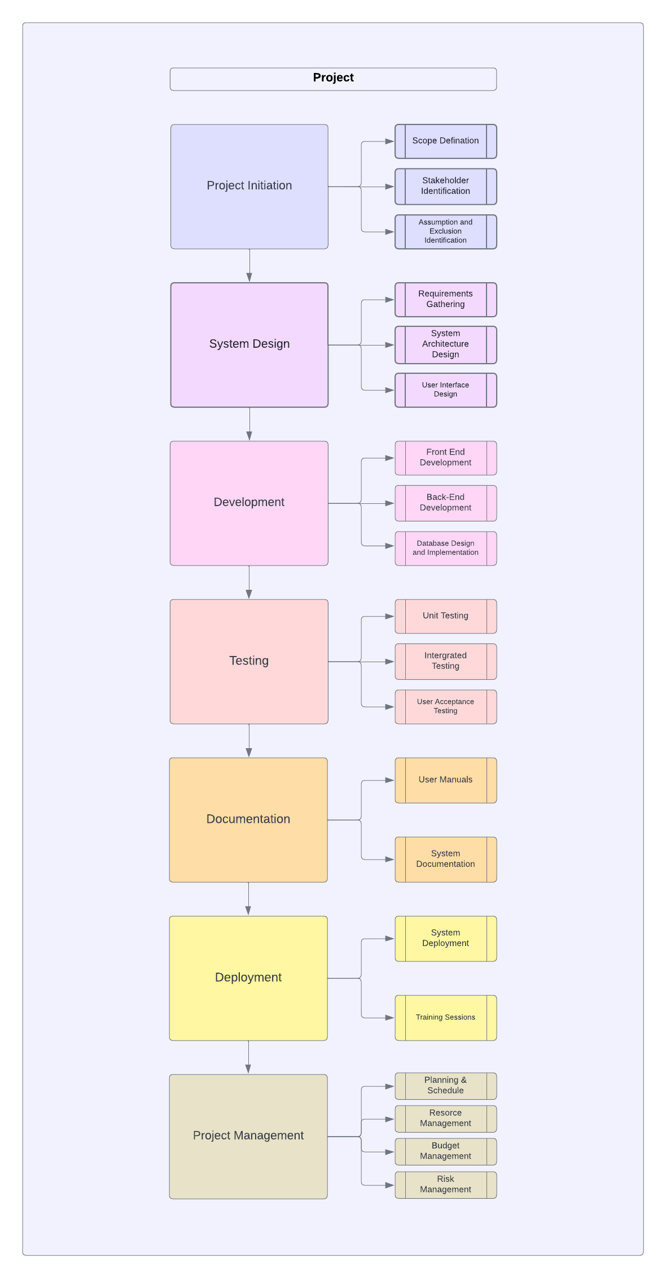

**3. Gantt Chart:**

|  |  |  |  |  |
| --- | --- | --- | --- | --- |
| Task | Start Date | End Date | Duration | Dependencies |
| Project Initiation | 01 Mar 2024 | 05 Mar 2024 | 5 days | None |
| System Design | 06 Mar 2024 | 12 Mar 2024 | 7 days | Project Initiation |
| Development | 13 Mar 2024 | 23 Apr 2024 | 6 weeks | System Design |
| Testing | 24 Apr 2024 | 15 May 2024 | 3 weeks | Development |
| Documentation | 16 May 2024 | 22 May 2024 | 1 week | Testing |
| Deployment | 23 May 2024 | 29 May 2024 | 1 week | Documentation |
| Project Management | 01 Mar 2024 | 29 May 2024 | 13 weeks | None |

**4. Organizational Structure:**

**Project Management Team:**

(This role would typically report to upper management Like Project Owner)

* Project Manager: David Doe
* Scrum Master: Zanele Magwaza

**Development Team:**

* Team Leader: Loyiso Gola

(Team Leaders manage developers)

* + Frontend Developers:
    - Philasande Bhani
    - Luxolo Mkwaqa
  + Backend Developers:
    - Sinovuyo Sikhisi
    - Sizwe Mthembu
    - Zandile Mthethwa

**Other Key Roles:**

* Business Analyst: John Smith (Business Analysts work closely with the Project Manager and Development Team)
* Tester: Simphiwe Zwane (Testers often collaborate with the Development Team)
* Database Administrator: Cleo Chlo (Database Administrators may collaborate with the Development Team and Project Manager)

**5. Budget:**

* **Estimated Budget:**
  + Development Resources: R50,000
  + Testing Tools and Licenses: R5,000
  + Documentation: R2,000
  + Training Sessions: R3,000
  + Contingency Reserve: R10,000 (10% of total budget)

**6. Change Control Process:**

* **Change Request Procedure:**
  + Any team member can submit a change request using the designated form.
  + Project Manager will review the change request and assess its impact on scope, schedule, and budget.
  + If approved, the change will be documented and communicated to relevant stakeholders. If rejected, reasons will be provided.
  + Changes will be implemented following proper documentation and approval procedures.